An Explainable Deep Learning Framework to Forecast Economic Uncertainty Using Social Media Data

ABSTRACT
In recent years, social media has become an indispensable source of information through which public attitudes, opinions, and concerns can be studied and quantified. This paper proposes a framework for predicting the Equity Market-related Economic Uncertainty Index using features generated from a popular discussion forum on Reddit. Our framework consists of a series of custom pre-processing and analytics methods, including BERTopic for latent topic identification and regularized linear models. Using our framework, we evaluate explanatory models with different configurations over a large corpus of Reddit posts belonging to the personal finance category. Our analysis generates valuable insights about discussion topics on Reddit and their efficacy in accurately predicting future economic uncertainty. The study demonstrates the potential of using social media data and explainable deep learning to inform economic forecasting and decision-making. It contributes to the information systems (IS) knowledge base by enabling economic forecasting using a novel analytics framework.
Keywords: Explainable Deep Learning, Topic Modeling, Unstructured Information Extraction, Social Media Analytics, Economic Uncertainty Analysis

INTRODUCTION
Global disasters have significantly disrupted human lives every few years. The Great Depression of 1929 led to a prolonged period of economic uncertainty and hardship. The Dot-com bubble in early 2000 caused many leading technology companies to shut down. The Global Financial Crisis of 2009 caused a deep recession, high unemployment rates, and long-lasting economic repercussions. The COVID-19 pandemic that started in late 2019, caused massive job losses, business closures, government stimulus measures, and a sharp decline in global economic output. Conflicts such as the Russia-Ukraine War that started in 2022 results in destruction of infrastructure, displacement of populations, and disruptions in trade and investment. Forecasting economic uncertainty plays a vital role in guiding decision-making, managing risks, formulating policies, maintaining market stability, influencing consumer behavior, and facilitating international trade. Accurate forecasts enable businesses, individuals, and governments to navigate uncertain economic conditions more effectively and mitigate potential adverse impacts. By understanding the level of uncertainty in the economy, companies can adjust their production, investment, and hiring strategies accordingly, optimizing their performance and minimizing potential losses. Furthermore, individuals can make informed decisions about their investments, savings, and retirement plans based on forecasts of economic uncertainty. By having accurate forecasts, policymakers can implement timely measures to stabilize the economy, manage inflationary pressures, and support sustainable economic growth.
Social media platforms have become an invaluable source of information for studying various social, economic, and political phenomena in modern society [21,33,39]. By analyzing the content of social media posts, we can gain valuable insights into the attitudes, behaviors, and concerns of a wide range of internet users. For example, social media data has been previously leveraged to examine the sentiments of investors toward public stocks and market indices [8,22,35]. Social media data has also been studied to characterize individual and organizational outcomes such as consumer behavior and firm equity value [1,38]. In a similar light, social media data can be considered a vital source of information for economic policymakers and financial analysts. This paper specifically explores the potential of using social media data to forecast economic uncertainty. We focus our interests on the Personal Finance subreddit and develop a framework for analyzing and predicting economic uncertainty. Through a series of experiments, we demonstrate the effectiveness of our approach and identify key topics that influence prediction performance.
To forecast economic uncertainty, we model the Economic Policy Uncertainty Index (EUI) introduced by Scott Baker, Nicholas Bloom, and Steven Davis [2] as a regression problem. The motivation of this study is that while Baker et al. computed EUI by parsing global news articles, few studies have examined the association between public sentiment and the economic uncertainty index. It is prudent to determine if and how online public sentiment is related to future economic uncertainty. Compared to news articles and microblogging platforms, discussion platforms such as Reddit provide a richer source of information that captures the public's concerns and offers insights into future economic uncertainty. Furthermore, learning the relationship between the social media discourse and EUI variations can contribute to the growing body of research on the role of social media in predicting economic trends and therefore be helpful for macroeconomists, policymakers, firms, and investors.
We collected and analyzed a set of Reddit conversations that specifically talks about personal financial-related issues from the end of 2021 till the mid of 2022. The analysis shows that the volume of particular topics from the conversations can be predictive of future economic uncertainty. Our study contributes to the existing literature in the following ways: (1) We introduce a unique method framework for extracting topics from Reddit using deep learning that can be used for modeling economic uncertainty index. (2) We identify the topics whose daily volume on social media platforms could potentially be predictive for future economic uncertainty assessment and interpretation, and (3) Identification and use of two complimentary evaluation metrics: normalized forecasting accuracy (NFA), and the Spearman’ Rank Correlation Coefficient (SC) for performance evaluation of economic uncertainty prediction models. Our research contributes to analytics research focused on modeling economic uncertainty using novel data sources. Using our framework, policymakers, businesses, and individuals can develop models that not only accurately forecast near-future economic uncertainty, but also inform about online discussion topics that are tied to imminent changes in economic activities. Our study contributes to IS research by introducing a new analytics method framework as a design science artifact as well as furthering social media analytics research geared towards economic uncertainty modeling.
The rest of the sections are presented as follows. Section 2 describes the research background. Section 3 introduces the data used in this study. In Section 4, we explain the analytics methods in detail. Section 5 discusses the analysis. In Section 6, the discussion and conclusions are presented.

RESEARCH BACKGROUND
The EUI index is based on the idea that newspaper text searches can provide useful proxies for economic and policy conditions, particularly in countries with limited data sources or in earlier periods. The authors showed that the EUI can effectively capture economic uncertainty stretching back several decades [2]. In particular, Equity Market-related Economic Uncertainty Index is a type of EUI that specifically measures the level of uncertainty present in the market. High levels of economic uncertainty are often associated with increased volatility in the stock market, as investors may be more hesitant to make decisions in an uncertain environment. By tracking the index, economists and financial analysts can get a sense of the level of uncertainty that is present in the market and use this information to make more informed decisions about investing and trading.
Explainable artificial intelligence (XAI) is a field of Artificial Intelligence (AI) that promotes a set of tools, techniques, and algorithms that can generate high-quality interpretable, intuitive, human-understandable explanations of AI decisions [7]. In particular, explainable deep learning is a discipline focused on the development of methods and studies enabling the explanation of decisions from deep learning models [30]. While fully parametric statistical models such as linear regression are widely used for explanatory modeling, their predictive power is lower due to high bias [34]. In comparison, XAI methods are gaining importance in explanatory modeling as they use complex multi-layered algorithmic models such as ensemble learners and deep neural networks to first predict a phenomenon followed by using ingenious approaches to interpret the underlying phenomenon by exploiting the structure of the trained model [26].
Social media platforms are rich with information about individual, organizational, and social behavior across time and geographies. behaviors. Studies have looked at causal as well as associative links between social media and stock market uncertainty [6,17,28]. Studies have also extracted timely economic signals beyond social media such as newspaper articles to improve forecasts of macroeconomic variables, such as inflation and unemployment [18,32]. An economic policy uncertainty index was also proposed by using a select set of Twitter accounts whose tweets are considered to reflect an expert opinion on economic policy issues [40]. Reddit is a discussion forum with users focusing on detailed conversations based on recent events and news articles [29]. Prior studies either analyze data from microblogging platforms such as Twitter or examine the role of news articles in changes in macroeconomic variables. Our analysis of Reddit and the Economic Policy Uncertainty addresses is the first to determine and model a potential relationship between the social media discourse and economic uncertainty using explainable deep learning techniques.

DATA
In our study, we aim to investigate whether social media data can be used to predict economic uncertainty. Therefore, the selection of an appropriate data source is critical. After reviewing publicly available curated data repositories, we determined that it would be beneficial to harvest new data from a suitable social media platform. Facebook, LinkedIn, and similar platforms primarily emphasize personal and business networking and not public broadcasts of personal socio-political opinions, thus making them unsuitable for our study. Twitter is a widely used source of data in which users commonly voice opinions about social and political issues. But the micro-blogs (i.e., tweets) generated by users are often brief and conversational, making it challenging to gather a large volume of data on a specific topic. In contrast, the posts on Reddit tend to be longer and more descriptive, therefore more suitable for our study.
The Reddit user community consists of different interest groups invested in numerous forums commonly known as subreddits. Literature in personal finance indicates a relationship between economic conditions and individual financial success [13], and reciprocally, it is hypothesized that the aggregated personal financial decisions and concerns may be reflected in the overall economic conditions. We identified the "Personal Finance" subreddit as particularly relevant for our research, given its focus on topics such as budgeting, saving, debt, credit, investing, and retirement planning. We believe that these user topics may be directly or indirectly linked to wider economic issues, as individual investment behavior and sentiments are impacted by the economy and vice versa. This subreddit has a membership of 17.1 million users and is currently ranked twenty-second in size across all of Reddit, making it a large and active community serving as a valuable source of data for our study.
In the rest of this section, we will delve into the details of our data acquisition process, including the methods used to collect and label the data, and the steps taken to prepare the data for analysis.
3.1 Raw Data Extraction
From November 23rd, 2021, to June 25th, 2022, we leveraged the Python Reddit API Wrapper, 'PRAW' [4], to scrape the posts and replies within the "Personal Finance" subreddit at one-hour intervals. This resulted in a data set spanning a 215-day period. The data set consists of features including Submission_Id, Reply_Id, Submission_title, Author, Date, Vote, and Text. The Submission_Id and Reply_Id will be the same for the main post, while the remaining features pertain to the corresponding submission or reply. Note that we experienced inconsistencies in the collection process due to internet and API outages on December 30th, 2021, and February 3rd, 2022, resulting in gaps in data extraction. A summary of the raw data is shown in Table 1.
Table 1 is placed here
3.2 Data Preprocessing
We performed multiple steps of data cleaning to prepare the dataset for modeling. These steps included removing documents with fewer than 10 tokens, as these tend to be less informative, eliminating all stop words and web links, dividing long documents into sentence-level units, and ensuring that no records contain more than 500 tokens. The resultant corpus contained 1,028,333 sentences, with an average word count of 42.57 per sentence.
3.3 Feature Engineering
We first identified topics across reddits (i.e., Reddit posts), using BERTopic [15], a deep learning method for topic modeling, described in detail in the next section. To determine the relationship between the identified topics in “Personal Finance” and the future value of EUI, we computed the EUI for a period of n days after the reddits were posted. We consider three values of $n$ in our study, one, three, and seven, to compare the different potential lagged effects of topics on economic uncertainty predictions. To account for endogeneity in the model, we include the following covariates in our model - day of the week, month of the year, and level of user activity at the time each topic was posted. The level of user activity is measured by the daily number of conversations captured from the subreddit forum and the number of active users on that given day. Those additional covariates are only used in the initial analysis for topic features, which will be discussed under the section of Analysis. We did not include any of these features in the forecast analysis.

OUR PROPOSED FRAMEWORK
In this section, we provide details of our method framework. First, we present a novel explainable topic modeling framework (TMF) based on BERTopic [15] to extract relevant topics and their frequency on each corresponding date across the Reddit posts. Second, we show how the features are filtered and reranked. Finally, we feed the outputs from step 2 as the inputs into a supervised deep learning TS model to estimate the future EUI. Figure 1 is an illustration of our whole framework combining step 1-3.
4.1 Topic Modeling
BERTopic is a topic modeling method based on word embedding [25] and transformer technologies [9]. It builds upon legacy topic modeling methods such as Latent Dirichlet Allocation (LDA) that are designed to extract coherent topic representations by identifying explicit relationships between words or phrases in the text [3]. In contrast, BERTopic generates document embeddings using the pre-trained transformer-based language model BERT [9], after reducing the dimensions and clustering of the embeddings, to generate topic representations using a class-based variation of the term frequency-inverse document frequency (c-TF-IDF) procedure [15]. c-TF-IDF can best be explained as a TF-IDF formula adopted for multiple classes by joining all documents per class and it can be seen as the importance scores for words within a cluster. It has been shown to generate coherent topics and to be competitive with other classical and more recent topic modeling approaches across various benchmarks. Identifying the optimal number of topics using metrics such as perplexity or coherence [27] can be computationally intensive. Therefore, in our framework, we propose to compare the performance of model configurations with different topic counts.
4.2 Feature Selection and Ranking
The BERTopic method can potentially identify thousands of topics from text like Reddit discussions. In our model, each topic is considered as an input feature. Therefore, feature selection becomes necessary to develop a meaningful model for economic uncertainty. Least Absolute Shrinkage and Selection Operator, i.e., Lasso, is a popular regularization-based feature selection method [37]. Lasso accomplishes variable selection by shrinking insignificant predictor variables’ coefficients to zero, particularly in high-dimensional data.
While L-1 regularization (i.e., lasso) is helpful for eliminating features that do not contribute to characterizing the outcome, it can still result in a large number of unranked features. Therefore, we implemented permutation importance to measure the importance of selected features in relation to EUI one day after posts are made with the help of a Python library called Eli5 [19]. Permutation feature importance is a model evaluation method that can be applied to any fitted estimator with tabular data, particularly useful for non-linear or complex models. It is defined as the decrease in model performance, which is measured by evaluation metrics like F1 or R2, when a single feature value is randomly shuffled [5]. By disrupting the relationship between the feature and the target, the decrease in model performance reflects the extent to which the model relies on the feature. The output from Eli5 is known in the literature as “Mean Decrease Accuracy (MDA)” or “permutation importance” [19]. To lower the computational cost, by default, we only select the top ten features from the permutation analysis.
4.3 Deep TS Forecasting
The goal of our forecasting task is to use a subset of history data to estimate the EUI for the next seven days. As we are predicting the EUI into multiple steps in the future and using the topic features, the whole prediction task is formulated as a multi-step timeseries forecasting problem.
LSTM, short for Long Short-Term Memory, has emerged as a highly popular and transformative recurrent neural network architecture in the realm of TS analysis. Its remarkable capabilities allow it to effectively capture long-term dependencies, handle variable-length sequences, model temporal dynamics, accommodate nonlinear relationships, and robustly handle noisy data. The widespread adoption of LSTM in various domains such as finance, energy, weather forecasting, and beyond is a testament to its unparalleled success in accurately modeling and predicting time-dependent phenomena. At the core of LSTM's architecture are essential components, including input gates, forget gates, and output gates, which enable the network to selectively retain and update information at each time step, ensuring efficient information flow and processing. However, employing LSTM for TS modeling requires a departure from conventional statistical models, necessitating the transformation of the task into a supervised learning paradigm. This involves utilizing historical values as inputs and treating future scores as outputs to train the LSTM model effectively. The basic mathematical formula of LSTM can be expressed as follows:
LSTM equation goes here. (1)
Incorporating additional regressors into the LSTM framework for TS forecasting involves restructuring the dataset in a manner akin to processing lengthy text documents. In natural language processing, breaking down long text data into smaller chunks is a common approach. Similarly, restructuring TS data entails transforming each data point into a list of vectors, where each vector corresponds to the relevant regressors. Subsequently, the data point is labeled with a vector of future target values, which is used for training and prediction. This dataset restructuring enables the LSTM model to effectively capture the relationships between the regressors and the target variable, leading to improved forecasting accuracy and the ability to capture the inherent complexities of time series data. By integrating these additional regressors into the LSTM architecture, researchers can leverage their predictive power to gain deeper insights and enhance the model's capability to capture the underlying patterns and dynamics within a time series.
Furthermore, based on traditional LSTM, which only considers past information, Bidirectional LSTM (BiLSTM) is developed to processes the sequence in both forward and backward directions simultaneously. This allows the model to capture not only the historical context but also the future context, resulting in a more comprehensive understanding of the temporal patterns in the data. Thus, as demonstrated in Figure 1, we introduce two BiLSTM layers as hidden layers followed by a Dense layer as output layer in our model.
Figure 1 is placed here
4.4 Evaluation Metrics
The selection of appropriate evaluation metrics is a pivotal aspect in validating our proposed framework within the realm of time series analysis. Several commonly employed metrics in this domain include Mean Absolute Error (MAE), Mean Squared Error (MSE), Root Mean Squared Error (RMSE), Mean Absolute Percentage Error (MAPE), and Mean Absolute Scaled Error (MASE). MAE quantifies the average difference between the forecasted and actual values, providing ease of interpretation. However, it may exhibit limited sensitivity towards outliers. MSE, on the other hand, is a squared version of MAE and can effectively penalize outliers. Nevertheless, the resulting metric value is presented in a less intuitive format. RMSE, the square root of MSE, preserves the original units of the time series, but the squared errors impede direct interpretation. MAPE, measured as the percentage deviation between actual and forecasted values, often serves as the baseline metric for time series models. It boasts interpretability and scale independence, enabling comparisons across different time series. However, MAPE encounters challenges when the actual values are close to or at zero, yielding infinite errors, and it tends to exhibit a bias towards under-forecasting. MASE, a widely used metric, accounts for seasonality when calculating errors and mitigates the erratic behavior of MAPE in the presence of near-zero actual values. Nevertheless, MASE can introduce complexities when attempting to explain its output. While these metrics offer valuable insights into model performance, it is crucial to select the most appropriate one based on the specific characteristics of the time series data and the evaluation objectives at hand.
Therefore, to evaluate the predictive component in the proposed framework, we chose a normalized forecasting accuracy (NFA) metrics based on Symmetric Mean Absolute Percentage Error (SMAPE) and the Spearman’ Rank Correlation Coefficient (SC). These metrics are carefully chosen for their validity, interpretability, and alignment with the nature of our task.
SMAPE is a suitable metric for evaluating the accuracy of forecasting methods because it is symmetric, meaning that it treats both positive and negative errors. SMAPE is scale-invariant, which means it is not affected by the magnitude of the actual or forecasted values, especially when the EUI can vary a lot from time to time. It allows for meaningful comparisons across different datasets or TS with varying scales. Moreover, SMAPE, by its nature, favors over-forecasting compared to MAPE who favors under-forecasting, which aligns with our objective of presenting a more conservative and safer projection of the EUI index to the audience. The equation of SMAPE is denoted as in Equation (2), where $F$ is the forecasted value and $A$ is the actual value.
 | $$SMAPE= \frac{1}{n} \sum_{t=1}^{n}{\frac{|F_{t}-A_{t}|}{(A_{t}+ F_{t})/2}}$$ | (2)
However, the standard SMAPE has a lower bound of zero and upper bound of 200, which makes it hard to intuitively interpret by human. Considering people tend to understand the idea of accuracy better than error percentage, we transformed the SMAPE into NFA by dividing the SMAPE by two and subtracting it from one. The equation of NFA is as follows:
 | $$NFA=100\%*\left\{1- \frac{1}{2} * \left( \frac{1}{n} \sum_{t=1}^{n}{\frac{\left|F_{t}-A_{t}\right|}{{\left(A_{t}+ F_{t}\right)}/2}}\right)\right\}=100\%*\left(1-\frac{SMAPE}{2}\right)$$ | (3)
We chose SC as another evaluation method because it can detect the monotonic relationship between two variables. The variables in a monotonic relationship frequently change together, albeit perhaps not always at the same rate. Since we are doing a multi-step forecasting into the future, while it is important to know the accuracy, it is also important to evaluate if the model can accurately forecast the movement of the EUI given limited information. Furthermore, an assessment that considers this kind of relationship can be helpful for benchmarking EUI predictions.
To calculate SC, the ranks of the values for each variable are obtained. The correlation is then computed as the covariance between the ranks divided by the product of the standard deviations of the ranks. The resulting correlation coefficient ranges from -1 to 1, where values close to 1 indicate a strong positive monotonic relationship, values close to -1 indicate a strong negative monotonic relationship, and values close to 0 indicate no monotonic relationship between the variables. The equation of the metrics is given in Equation (4), where $d_{i}$ is the difference between the two ranks of each observation.
 | $$SC= \frac{6\sum{d_{i}^{2}}}{n(n^{2}-1)}$$ | (4)
While NFA and SC are both used to evaluate model performance, they assess different aspects of the proposed model. NFA focuses on quantifying the overall accuracy of predicted values, providing a measure of how closely the forecasts align with the actual values. On the other hand, SC goes beyond accuracy and examines the model's ability to capture the underlying trends in the TS. A high SC indicates that the model can effectively simulate the directional movements of the TS, regardless of the specific magnitude of the forecasts. It highlights the model's capacity to identify whether the TS will experience upward or downward trends within a given period. It is important to note that a high NFA does not guarantee a high SC, as accuracy and trend capturing are distinct aspects. To illustrate this, consider a scenario where the actual values are $actual=[10, 11, 12, 13, 14]$, and we have two sets of predicted values: ${forecast}_{1}=\left[1, 2, 3, 4, 5\right]$ and ${forecast}_{2}=\left[11, 10, 9, 13, 12\right]$. The NFA for ${forecast}_{1}$ is 37.73%, while its SC is 1. In contrast, the NFA for ${forecast}_{2}$ is 93.70%, with an SC of 0.5. These examples illustrate how NFA and SC capture different aspects of model performance, highlighting the need to consider both metrics for a comprehensive evaluation.

ANALYSIS
Following the raw data generation, data processing, and feature engineering, described in the data section, we applied our method framework to develop an explainable model over the Reddit dataset for economic uncertainty forecasting. The analysis consists of four steps: initial analysis for optimal number of features, features selection and ranking, forecasting analysis, and post forecasting analysis. All the experiments are conducted in Google Colab with an NVIDIA A100 Tensor Core GPU.
5.1 Experimental Setup
To analyze the daily frequency of each topic, we obtained the topic group for each corresponding date and aggregated them. However, due to computational constraints, we were unable to determine the optimal number of topics solely based on perplexity, as calculating probabilities using BERTopic is computationally intensive. Therefore, we compared the performance of the model with a set of fixed numbers of topics, including 10, 30, 50, 100, and 200. In addition, we also obtained a set of 2504 topics by allowing the model to automatically generate the optimal number of topics based on the distance strength set in the clustering algorithm. This resulted in a total of six sets of data.
Our experimental configuration for initial analysis comprises six datasets, each labeled with three future periods of EUI, yielding a total of 18 pairs for comparison between the number of topics and future periods. The dataset itself encompasses a significant number of features, potentially exceeding 2500+. Using the Lasso method, we retained only contributing predictors in the input feature set. Thereafter, we conducted a permutation analysis with a Random Forest Regressor (Leo Breiman 2001; Pedregosa et al. 2011) with default parameters in Python’s scikit-learn package for 10-fold cross validation in 100 iterations.
We benchmark a strong baseline for EUI prediction with a traditional statistical TS model – Prophet. After that, we use a multimodal modeling strategy to assess the predictive power of top-10 features generated using our framework. Then we compare the baselines against a Long Short Term Memory (LSTM) based model to explore how well the deep learning approach can generalize the information embedded in the conversations on Personal Finance.
Prophet [36] is an additive forecasting method designed for modeling TS with non-linear trends, seasonality, and holiday information. We decided to use Prophet as a baseline as it is one of the state-of-the-art methods used for time-series forecasting [10]. The Prophet model can be represented as follows:
 | $$y_{t}=g\left(t\right)+s\left(t\right)+h\left(t\right)+ϵ_{t}$$ | (4)
In Equation (4), $y_{t}$ is the value of the TS at time $t$, $g(t)$ is the trend component modeling non-periodic changes, $s(t)$ is the component for capturing the seasonal changes, $h(t)$ represents the effects of holidays that occur on potentially irregular schedules over one or more days, and $ϵ_{t}$ represents any idiosyncratic changes. Prophet has been shown to be better than data mining models for time-series data. This is because the latter leads to data leakage as it ignores feature autocorrelations.
To improve the forecasting accuracy of the FB Prophet model, we incorporate the top-K most important features generated from feature importance analysis into the baseline model and conduct another round of simulation. This process is called as a multimodal modeling approach [20]. In this process, we use multiple modalities of data to improve the accuracy and robustness of the baseline model. The equation of the transformed model with the additional ten features is as follows:
 | $$y_{t}=g\left(t\right)+s\left(t\right)+h\left(t\right)+ \sum_{i∈T}{v(i_{t})}+ϵ_{t}$$ | (5)
In Equation (5), $v(i_{t})$ is the volume of a given topic specific topic $i$ on a given day $t$, and $T$ is the set of all topics. Equation (5) is similar to ARIMAX models, where the TS is modeled as an auto-regressive integrated moving average with exogenous variables X [12]. However, our model uses PROPHET which has added benefits over the traditional ARIMA family of time-series models. It is more interpretable as it decomposes the TS into trend, seasonal, irregular scheduled interruptions (e.g., public holidays), and a random component. Further, PROPHET has also been shown to have a better fit compared to ARIMA classes of models, thus enhancing the internal validity of our final feature importance estimates.
To evaluate the baseline model, Prophet, we employ a walk-forward approach with a training period of 90 days to forecast the outcome for the next 7 days. Each training set consists of 90 observations, and the walk-forward approach generates a total of 118 TS with and without the select topic features in our study, respectively. The testing period starts from February 21, 2022, and ends on June 18, 2022. Using 3,000 Markov chain Monte Carlo (MCMC) draws, the Prophet model is fitted to each TS. By comparing the predicted values to the actual values, we can benchmark the performance of the Prophet model. The same approach is applied to the proposed LSTM model. Each training set contains 90 days of data, with a training window size of 28 days. The target value is labeled with the EUI of the following day. This results in 56 pairs of window and target in each training set. To further investigate the effects of topics on multi-step forecasting, we created an additional control group. We transform the multi-step LSTM models into a single-step LSTM model and train it on TS with 90 days of data. The window size is set to 28, resulting in 62 pairs of window and target in each TS. For all the LSTM-based models, we employ the mean absolute error (MAE) as the loss function. To mitigate the risk of overfitting, we incorporate a validation data set by randomly allocating 20% of the training data for validation purposes. Early stopping is implemented with a patience of three, allowing the model to halt training if the validation loss fails to improve. Additionally, to enhance model regularization, we introduce an L2 regularizer with a strength of 0.05 on the second BiLSTM layer. This regularization technique aids in controlling the complexity of the model and helps prevent overfitting.
In total, we have five groups of models for forecasting analysis: multi-step Prophet, multi-step Prophet with Topic Features, multi-step LSTM, multi-step LSTM with Topic Features, and single-step LSTM with Topic Features. Comparing these groups allows us to examine and understand the performance of different models in forecasting multi/single-step outcome(s) while considering the influence of topic features.
5.2 Initial Analysis for the Generated Topic Features
For the topic modeling step of our framework, we generated sentence embeddings using the pre-trained model all-mpnet-base-v2 from SentenceTransformers [31], reduced the embedding dimensions using the UMAP procedure [24], clustered the documents using the HDBSCAN method [11,23] and finally derived the topic representations using the c-TF-IDF method [15]. Note that the base method of BERTopic [15] offers the flexibility to change the components of our framework to any widely used software (i.e., K-means can be used instead of HDBSCAN for clustering, PCA can be used for dimension reduction instead of UMAP, etc.). Our choices of methods were based on interim experiments conducted toward improving our overall model’s performance.
In order to explore the potential relationship between the number of topics and their corresponding EUI, as well as to determine the optimal number of topics to retain, we conducted a comprehensive cross-validation analysis using RandomForest as the underlying model. The outcomes of this analysis are presented in Table 2. Notably, the models employing a higher number of topics demonstrated superior performance in predicting the EUI one day following the posts, exhibiting a notable NFA of 77.18% with a standard deviation of 0.59% and a robust Spearman Correlation coefficient of 0.313.
Table 2 (a) is placed here
Table 2 (b) is placed here
We performed feature selection using Lasso with the dataset that has 2504 topics and found that the combination with the best performance resulted in a final count of selected features as 194, which means approximately 92.27% of topics were filtered out. This set of features will be taken forward for further selection and ranking based on the feature importance derived from permutations.
5.3 Feature Selection and Ranking
In the initial stages, we possessed information solely on the daily counts of individual features without any understanding of their respective contributions to forecasting accuracy. To address this knowledge gap, we conducted permutation analysis, which provided us with intuitive feature importance scores for each of the 194 features. Subsequently, we reevaluated the rankings based on these importance scores and retained only the top 10 features for further analysis due to computational constraints. Figure 2 presents the permutation importance results for the top 10 topics after 100 iterations using 10-fold cross-validation.
Figure 2 is placed here
Figure 3 shows the correlation between EUI and each topic. Based on the analysis presented in Figure 3, we observe a positive correlation between the EUI and the discussions related to Rental Property Management, Pension Planning and Management, Social Security Benefits, and Alcoholic Beverages Consumption. Conversely, we observe a negative correlation between the EUI and discussions pertaining to Retirement Investment Options, Stock Market, Land Use and Development, Accounting and Taxation, Buying and Selling of Financial Products, and Medical Billing and Collections.
Figure 3 is placed here
5.4 Prediction Evaluation
The model represented by Equation (2) is estimated using Monte Carlo simulations. As the model structure becomes more complex, MCMC sampling tends to reach saturation and may become trapped in local maxima. To prevent the model from becoming saturated, we set the adapt_delta parameter to 0.95 (default is 0.8) and the maxtreedepth parameter to 15 (default is 10) for each TS. In Bayesian inference, the No-U-Turn Sampler (NUTS) is a widely used method for sampling from the posterior distribution [16]. To achieve efficient sampling, a key tuning parameter is adapt_delta, which controls the step size for NUTS by adjusting the acceptance probability for each candidate point in the Markov chain. Choosing a high adapt_delta allows for larger steps but may result in slower convergence [14]. In contrast, selecting a lower value will lead to a smaller number of steps yet may converge faster. In addition, we also tuned the maxtreedepth parameter, which defines the maximum depth of the binary tree used in the sampling process. By setting a higher maxtreedepth value, the sampler can explore a more complex model space, but this may lead to longer computational times and higher memory requirements. Conversely, setting a lower value restricts the exploration of complex models but can result in faster sampling.
Figure 4 displays the 7-day average NSF from all five models that includes the daily volume of the additional 10 topics as regressors. Figure 5 shows the results of 7-day SC coefficient of each TS. Table 4 summarizes the overall performance for each candidate model. The PROPHET model without additional features is denoted as BaseProphet and the PROPHET model with the topic features is denoted as TopicProphet. The same naming convention is applied to the multi-step LSTM models too. The single-step LSTM model with features is denoted as Topic LSTM - Single.
Table 4 is placed here
According to Figure 4, Topic LSTM (the line in red) achieved the best NFA of 87.36% with a standard deviation of 5.01%. The NFA of both Topic LSTM and Topic LSTM – Single never dropped below 70% across the testing periods. Topic Prophet illustrates the worst performance among the candidate models with an average NFA of 69.80% along with a standard deviation of 12.89%.
Figure 4 is placed here
Figure 5 highlights that Topic LSTM – Single displays a dominating performance in terms of SC. Especially before the mid of April of 2022, the model’s performance is very consistent. The SCs of the rest of the candidate models don’t show significant difference.
Figure 5 is placed here
According to Table 4, we notice that the performance of Prophet actually dropped after including more topic features. This phenomenon leads us to suspect that the traditional additive model has a difficult time of generalizing the information given a long training period (i.e., 90 days.). After several rounds of testing, we found that by carefully tweaking the parameters, Topic Prophet model displays better NFAs with short training periods. One of the examples is shown in Figure 6. We observed that the NFA of Topic Prophet increased by roughly 5% compared to the Base Prophet for the 28-day training period case. With a 90-day training period, the Topic Prophet’s NFA was roughly 6.4% less than the Base Prophet. We conducted a one-way ANOVA to assess the differences in the performance of those two models. The results indicated a significant difference between the results of the two models (F-statistic = 20.07, p < 0.01) for the 28-day training period case.
Figure 6 is placed here

DISCUSSION AND CONCLUSIONS
Forecasting economic uncertainty is of paramount importance for several reasons. Accurate forecasting of economic uncertainty helps policymakers make informed and strategic decisions. It enables them to anticipate potential risks, plan for contingencies, and allocate resources effectively. Economic uncertainty poses risks to businesses and individuals as well. By understanding the level of uncertainty in the economy, companies can adjust their production, investment, and hiring strategies, and accordingly, optimize their business processes to minimize potential losses. Forecasting helps identify and quantify these risks, allowing for effective risk management strategies to be put in place. On the other hand, individuals can make informed decisions about their investments, savings, and retirement plans based on forecasts of economic uncertainty. In general, accurate forecasts of economic uncertainty can provide individuals with a clearer understanding of the economic landscape, helping them make informed choices about their consumption, savings, and borrowing.
Social media plays a complex and multifaceted role in the context of forecasting economic uncertainty. While it is not a direct tool for forecasting, it can provide valuable insights and contribute to understanding and predicting economic trends. Social media platforms generate vast amounts of real-time data, capturing the opinions, sentiments, and behaviors of individuals. This data can be mined and analyzed to gain insights into public sentiment towards the economy. Secondly, social media platforms serve as a rapid and widespread source of information. Economic news, reports, and data are disseminated and shared on social media, reaching a large and diverse audience. This enables faster access to information for analysts and researchers, facilitating quicker analysis and forecasting of economic uncertainties. Lasty, discussions, opinions, and trends on social media have the potential to create a ripple effect. They can affect consumer confidence, spending patterns, and investment decisions, thus, indirectly impacting the economy.
Social media platforms such as Reddit provide a forum for individuals to discuss and share their reactions to economic news and events. By monitoring discussions and posts in reddit related to economic topics, we show that it is possible to detect emerging issues before they are reflected in traditional economic indicators. In this study, we model the Economic Policy Uncertainty Index (EUI) invented by Scott Baker, Nicholas Bloom, and Steven Davis using past information contained in a sub-group of users of Reddit.com, a popular social media platform dedicated to discussion of variety of subjects. To the best of our knowledge, our study is the first to use conversations on Reddit to forecast EUI and uncover insights about future economic direction. Our proposed framework exhibits the outstanding performance in terms of NFA for predicting EUI scores of seven days following the creation of posts or replies on the "Personal Finance" subreddit, as well as good performance of SC for predicting the EUI scores one day after the reddit thread was posted. Among the base training sets, the data set with the most topics automatically optimized by the BERTopic algorithm outperforms the other datasets in five out of six instances. The Lasso method effectively filters out 92.27% of the total features. After conducting permutation analysis, we identified ten topics that have the greatest impact on predictions for the next day's EUI scores.
Following the findings from Figure 2 and Figure 3, we dive into the details and analyze the topics making contributions to the predictions. The topics are manually categorized into the following: Retirement Investment Options (Topic #0), Rental Property Management (Topic #19), Stock Market (Topic #30), Land Use and Development (Topic #54), Accounting and Taxation (Topic #74), Pension Planning and Management (Topic #82), Buying and Selling of Financial Products (Topic #158), Medical Billing and Collections (Topic #233), Social Security Benefits (Topic #272), and Alcoholic Beverages Consumption (Topic #318).
The listed topics are often related to financial stress and insecurity. For instance, an increase in discussions about renting or leasing could suggest that people are unable to afford home ownership, having issues with on-time payments, or seeking alternatives for housing, which potentially indicates economic strain. Similarly, increased discussions about tax-related issues may indicate that people are facing financial challenges or uncertainty and seeking professional assistance in financial planning and management. Pension management, medical billing and collections, and social security benefits are often related to financial insecurity in the context of healthcare, employment, and retirement. An increase in the volume of such conversations is likely to reflect increased economic uncertainty and financial insecurity among the people discussing them. For example, more frequent discussions about pension or social benefits may suggest concerns about financial security in retirement or difficulties related to unemployment, while an increase in discussions about hospital discharge bills or early withdrawal from 401(k) may indicate financial challenges related to healthcare costs or uncertainty about future sources of income. Conversations over buying and selling of financial products and stock markets are also the core topics as people’s behavior is influenced by their perception of the current economic conditions and their expectations of future economic conditions. When individuals are uncertain about the direction of the economy, they may become hesitant to invest in the stock market or purchase financial products. This uncertainty can lead to changes in conversation and behavior, such as increased discussion about the risks and benefits of different investments, or a reluctance to make large financial decisions. The topic regarding the consumption of alcoholic beverages is an interesting one on the list. The topic may be indicative of the level of personal economic stress and well-being because individuals who are experiencing financial stress may turn to alcohol as a means of coping with their financial problems. Therefore, when conversations over these topics pile up in the subreddit, the sentiment of an individual’s perception towards the current and future economy is captured.
6.1 Managerial Implications
According to Figure 4, the 7-day average NFA increased by 11.12% from the Base Prophet model and 17.56% from the Topic Prophet Model compared to our proposed Topic LSTM model. Our analysis suggests that discussions related to money retrieval, management of pensions and social security, or consumption of alcohol within the Personal Finance subreddit may reflect a buildup of concern among individuals towards future economics and possibly be predictive of an increase in economic uncertainty. Conversely, an increase in conversations about spending money or investment planning may indicate a greater faith in the current economic situation and suggest a potential decrease in the EUI.
We do not make any causal claims in this study while examining the value of social media signals in economic uncertainty forecasting models. Although the volume of topics alone cannot result in changes to the EUI, it can indicate a correlation between peoples’ major concerns and the future uncertainty embedded in economics. Recurring and prominent topics across discussions serve as a reflection of public feelings and perceptions of the economy, which is dynamic, descriptive, and non-trial to quantify.
The information presented in Figure 4 indicates that such integration of the volume change in relevant topics did not consistently improve forecasting accuracy. Specifically, the proposed model failed to outperform the other four candidate models in 39 out of 118 trials. To better understand the underlying factors that impede the effectiveness of topic features, we conducted a detailed analysis of the data. Our investigation highlights the significance of several factors that may influence the relationship between topic features and forecasting accuracy.
Our analysis started with an exploration of the EUI target values across different scenarios. The original data set showed a high level of volatility, with an average EUI of 103.41 and a standard deviation of 66.70. Further investigation into the 39 trials where the proposed model failed to improve performance over the other four models revealed an average EUI of 105.74 with a standard deviation of 61.71. However, for trials where the model's performance increased from the other models, the average EUI was 111.53 with a standard deviation of 64.39. These findings suggest that the integration of the volume of relevant topics into the TS could not significantly improve forecasting accuracy when the EUI centered around the mean of the sample. However, when the EUI fluctuates and potentially spike up, including the topic features can more effectively capture the trend.
Our investigation also revealed an intriguing pattern regarding the volume of conversations related to Alcohol Beverages Consumption. Specifically, we found that the average number of discussions in trials where the final model failed to beat the baseline was nearly four times higher than in trials where the model's performance increased. And we didn’t observe any major differences for other topics under different scenarios. This finding raises the possibility that the ambiguous nature of alcohol consumption, which can be associated with both positive and negative connotations such as stress relief or celebration, could create noise and mislead the forecasting model.
The changes in the volume of the topics mentioned in this paper are not the direct cause of the changes in EUI. Rather, these signals could be predictive of the future EUI as they reflect individuals' sentiments towards the current and future economy. These sentiments may be influenced by a variety of factors, including news, personal life events, employment changes, and investment losses. Therefore, even though the topical features did not significantly improve the forecasting performance, our study demonstrates that the conversations taking place on this subreddit can be both descriptive and predictive of the future economic direction.
6.2 Limitations and Future Work
Given computational limitations, we were unable to conduct an exhausting exploratory analysis and process all sentences in the data set. Additionally, as the sentence transformers cannot handle long texts, we had to cut the text into fixed-length chunks. This slicing process results in broken semantics of each chunk. Moreover, each chunk will only be labeled with one topic, thus some of the labels possibly only captured the meaning of local syntax yet ignored the full context and authors’ original intentions.
As a next step, we plan to uncover the insights from the posts from a different perspective. Currently, we only take the volume change in specific topics into consideration when performing the forecasts. A bunch of information has been lost during the topic generation process and feature selection process. We assume that the summarization of the major posts on each day may help us retain more information. Instead of solely working with the topic volumes, we can also process the summarization of each days conversation to further boost the forecasting performance.
6.3 Conclusions
Our study presents a deep learning framework for analyzing and predicting the Equity Market-related Economic Uncertainty Index using data from the "Personal Finance" subreddit. The framework consists of text standardization, feature engineering, topic extraction, dimension reduction, cross-validation, and EUI calculation modules. We conducted 18 modeling experiments with various combinations of the number of topics and future EUI scores. The best estimator was found to be the one with 2504 original topics automatically generated by BERTopic for EUI prediction one day after posts and replies were made. Some of the top topics influencing prediction performance include retirement investment, social security benefits, renting, pension, medical bills, etc. A change in the volume of posts containing these topics can serve as an indicator of economic fluctuations. Our study hints that online special-interest groups often get an intuition about dramatic changes occurring in the macro-environment and therefore express their sentiments that may be predictive of future economic conditions.

REFERENCES
1. Ashish, K.R., Bezawada, Kumar, A., et al. From Social to Sale: The Effects of Firm Generated Content in Social Media on Customer Behavior. Journal of Marketing, 53, 9 (2018), 1689–1699.
2. Baker, S.R., Bloom, N., and Davis, S.J. Measuring economic policy uncertainty. Quarterly Journal of Economics, 131, 4 (2016), 1593–1636.
3. Blei, D.M., Ng, A.Y., and Jordan, M.I. Latent dirichlet allocation. The Journal of Machine Learning Research, 3, (March 2003), 993–1022.
4. Boe, B., Payne, J., and P., A.D. No Title. The Python Reddit API Wrapper, PRAW, 2014.
5. Breiman, L. Random Forests. Machine Learning, 45, 1 (2001), 5–32.
6. Chaudhary, R., Bakhshi, P., and Gupta, H. Volatility in International Stock Markets: An Empirical Study during COVID-19. Journal of Risk and Financial Management, 13, 9 (2020).
7. Das, A. and Rad, P. Opportunities and Challenges in Explainable Artificial Intelligence (XAI): A Survey. (June 2020).
8. Deng, S., Huang, Z., Sinha, A.P., and Zhao, H. The interaction between microblog sentiment and stock returns: An empirical examination. MIS Quarterly, 42, 3 (2018).
9. Devlin, J., Chang, M.W., Lee, K., and Toutanova, K. BERT: Pre-training of deep bidirectional transformers for language understanding. 2019.
10. Ensafi, Y., Amin, S.H., Zhang, G., and Shah, B. Time-series forecasting of seasonal items sales using machine learning – A comparative analysis. International Journal of Information Management Data Insights, 2, 1 (2022).
11. Ester, M., Kriegel, H.-P., Sander, J., and Xu, X. A Density-Based Algorithm for Discovering Clusters in Large Spatial Databases with Noise. in KDD (Vol., 96, (1996), 226–231.
12. Friedman, J., Hastie, T., and Tibshirani, R. The Elements of Statistical Learning. 2001.
13. Garman, E.T. and Forgue, R. Personal Finance. Cengage Learning, 2014.
14. Gelman, A., Carlin, J.B., Stern, H.S., Dunson, D.B., Vehtari, A., and Rubin, D.B. Bayesian Data Analysis. CRC press, Boca Raton, FL, 2014.
15. Grootendorst, M. Neural Topic Modeling with a Class-Based TF-IDF Procedure. BERTopic, 2022.
16. Hoffman, M.D. and Gelman, A. The no-U-turn sampler: Adaptively setting path lengths in Hamiltonian Monte Carlo. Journal of Machine Learning Research, 15, (2014).
17. John, K. and Li, J. COVID-19, volatility dynamics, and sentiment trading. Journal of Banking and Finance, 133, (2021).
18. Kalamara, E., Turrell, A., Redl, C., Kapetanios, G., and Kapadia, S. Making text count: Economic forecasting using newspaper text. Journal of Applied Econometrics, 37, 5 (2022), 896–919.
19. Korobov, M. and Lopuhin, K. Eli5. 5, 2016. https://eli5.readthedocs.io/en/latest/.
20. Kress, G.R. Multimodality: A Social Semiotic Approach to Contemporary Communication. Taylor & Francis, 2010.
21. Kurumathur, S.K., Bhatt, P., Hariharan, G., Valecha, R., and Rao, H.R. Examining the Public Response to Vigilantism: A Multi-dimensional Model of Social Media Discourse. ICIS 2022 Proceedings, (December 2022).
22. Maqsood, H., Mehmood, I., Maqsood, M., et al. A local and global event sentiment based efficient stock exchange forecasting using deep learning. International Journal of Information Management, 50, (February 2020), 432–451.
23. McInnes, L., Healy, J., and Astels, S. Hdbscan: Hierarchical Density Based Clustering. The Journal of Open Source Software, 2, (2017), 11.
24. McInnes, L., Healy, J., and Melville, J. Uniform Manifold Approximation and Projection for Dimension Reduction. UMAP, 2020.
25. Mikolov, T., Sutskever, I., Chen, K., Corrado, G., and Dean, J. Distributed representations ofwords and phrases and their compositionality. In Advances in Neural Information Processing Systems. 2013.
26. Molnar, C. Interpretable Machine Learning. A Guide for Making Black Box Models Explainable. Book, (2020).
27. Newman, D., Lau, J.H., Grieser, K., and Baldwin, T. Automatic evaluation of topic coherence. In NAACL HLT 2010 - Human Language Technologies: The 2010 Annual Conference of the North American Chapter of the Association for Computational Linguistics, Proceedings of the Main Conference. 2010.
28. Ortiz, D.P. Economic policy statements, social media, and stock market uncertainty: An analysis of Donald Trump’s tweets. Journal of Economics and Finance, (2022).
29. Proferes, N., Jones, N., Gilbert, S., Fiesler, C., and Zimmer, M. Studying Reddit: A Systematic Overview of Disciplines, Approaches, Methods, and Ethics. Social Media and Society, 7, 2 (2021).
30. Ras, G., Xie, N., van Gerven, M., and Doran, D. Explainable Deep Learning: A Field Guide for the Uninitiated. Journal of Artificial Intelligence Research, 73, (2022), 329–396.
31. Reimers, N. and Gurevych, I. Sentence-BERT: Sentence embeddings using siamese BERT-networks. In E. Conference, ed., EMNLP-IJCNLP 2019 - 2019 Conference on Empirical Methods in Natural Language Processing and 9th International Joint Conference on Natural Language Processing, Proceedings of the Conference. 2019, pp. 3982–3992.
32. Ryu, P.M. Predicting the unemployment rate using social media analysis. Journal of Information Processing Systems, 14, 4 (2018).
33. Sachin, P.K., Schecter, A., and Li, W. Emotions in Microblogs and Information Diffusion: Evidence of a Curvilinear Relationship. In ICIS 2022 Proceedings. 2022, pp. 2471.
34. Shmueli, G. and Koppius, O.R. Predictive analytics in information systems research. MIS Quarterly: Management Information Systems, (2011).
35. Singh Chauhan, S., Srinivasan, K., and Sharma, T. A trans-national comparison of stock market movements and related social media chatter during the COVID-19 pandemic. Journal of Business Analytics, (2022).
36. Taylor, S.J. and Letham, B. Forecasting at Scale. The American Statistician, 72, 1 (January 2018), 37–45.
37. Tibshirani, R. Regression Shrinkage and Selection Via the Lasso. Journal of the Royal Statistical Society, Series B (Methodogical), pp, (1996), 267–288.
38. Velichety, S. and Shrivastava, U. Quantifying the impacts of online fake news on the equity value of social media platforms – Evidence from Twitter. International Journal of Information Management, 64, (June 2022), 102474.
39. Wang, Y., Ramaprasad, J., and Gopal, A. Dancing to the #challenge: The Effect of TikTok on Closing the Artist Gender Gap. ICIS 2022 Proceedings, (December 2022).
40. Yeşiltaş, S., Şen, A., Arslan, B., and Altuğ, S. A Twitter-Based Economic Policy Uncertainty Index: Expert Opinion and Financial Market Dynamics in an Emerging Market Economy. Frontiers in Physics, 10, (2022).

FIGURES AND TABLES
List of Figures:

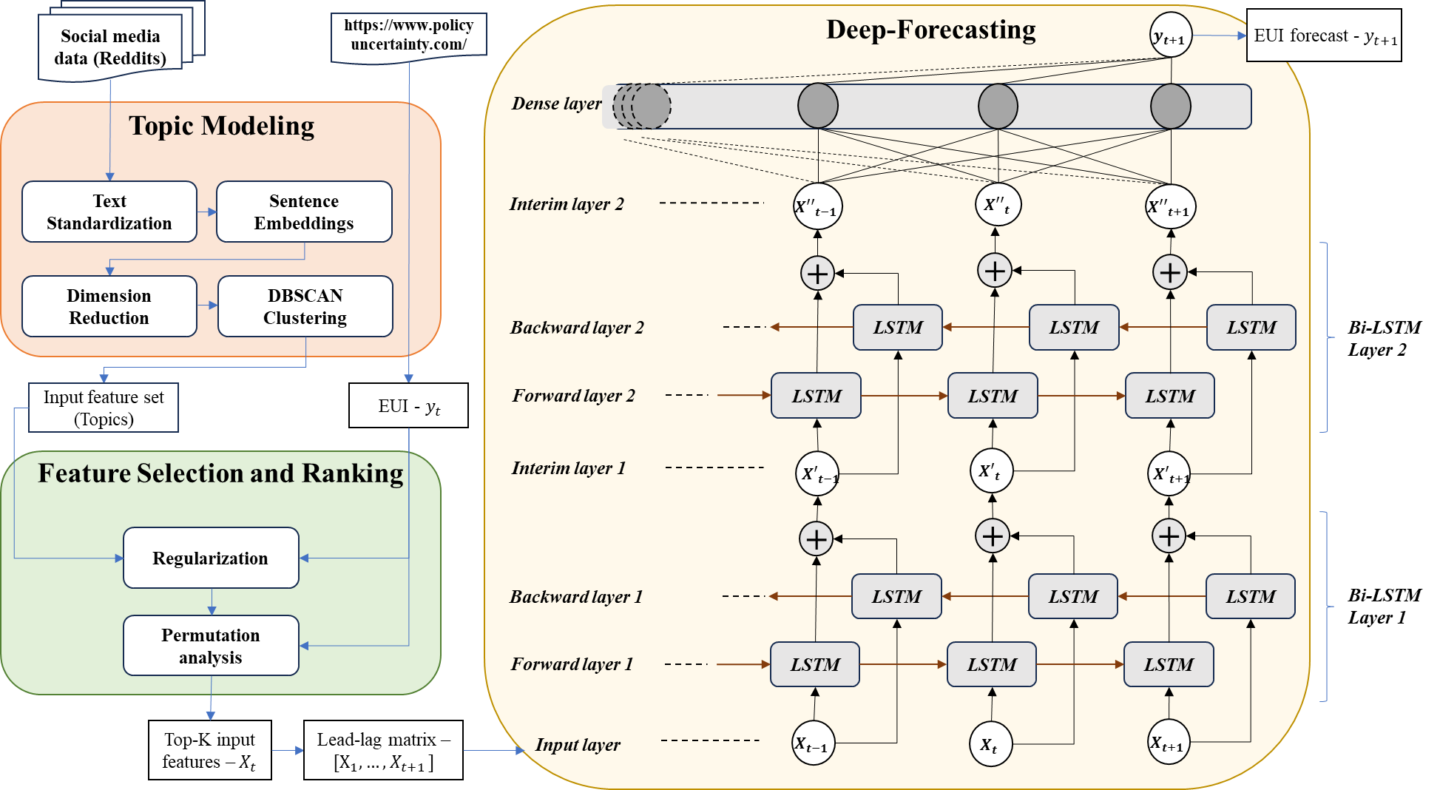
Figure 1. Method Framework for Determining Economic Uncertainty Using Reddit Text

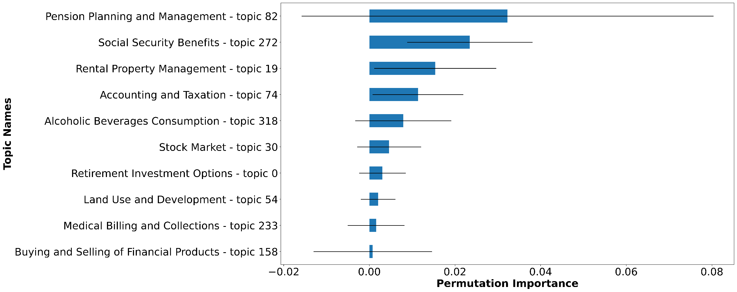
Figure 2. Permutation results for the top ten features

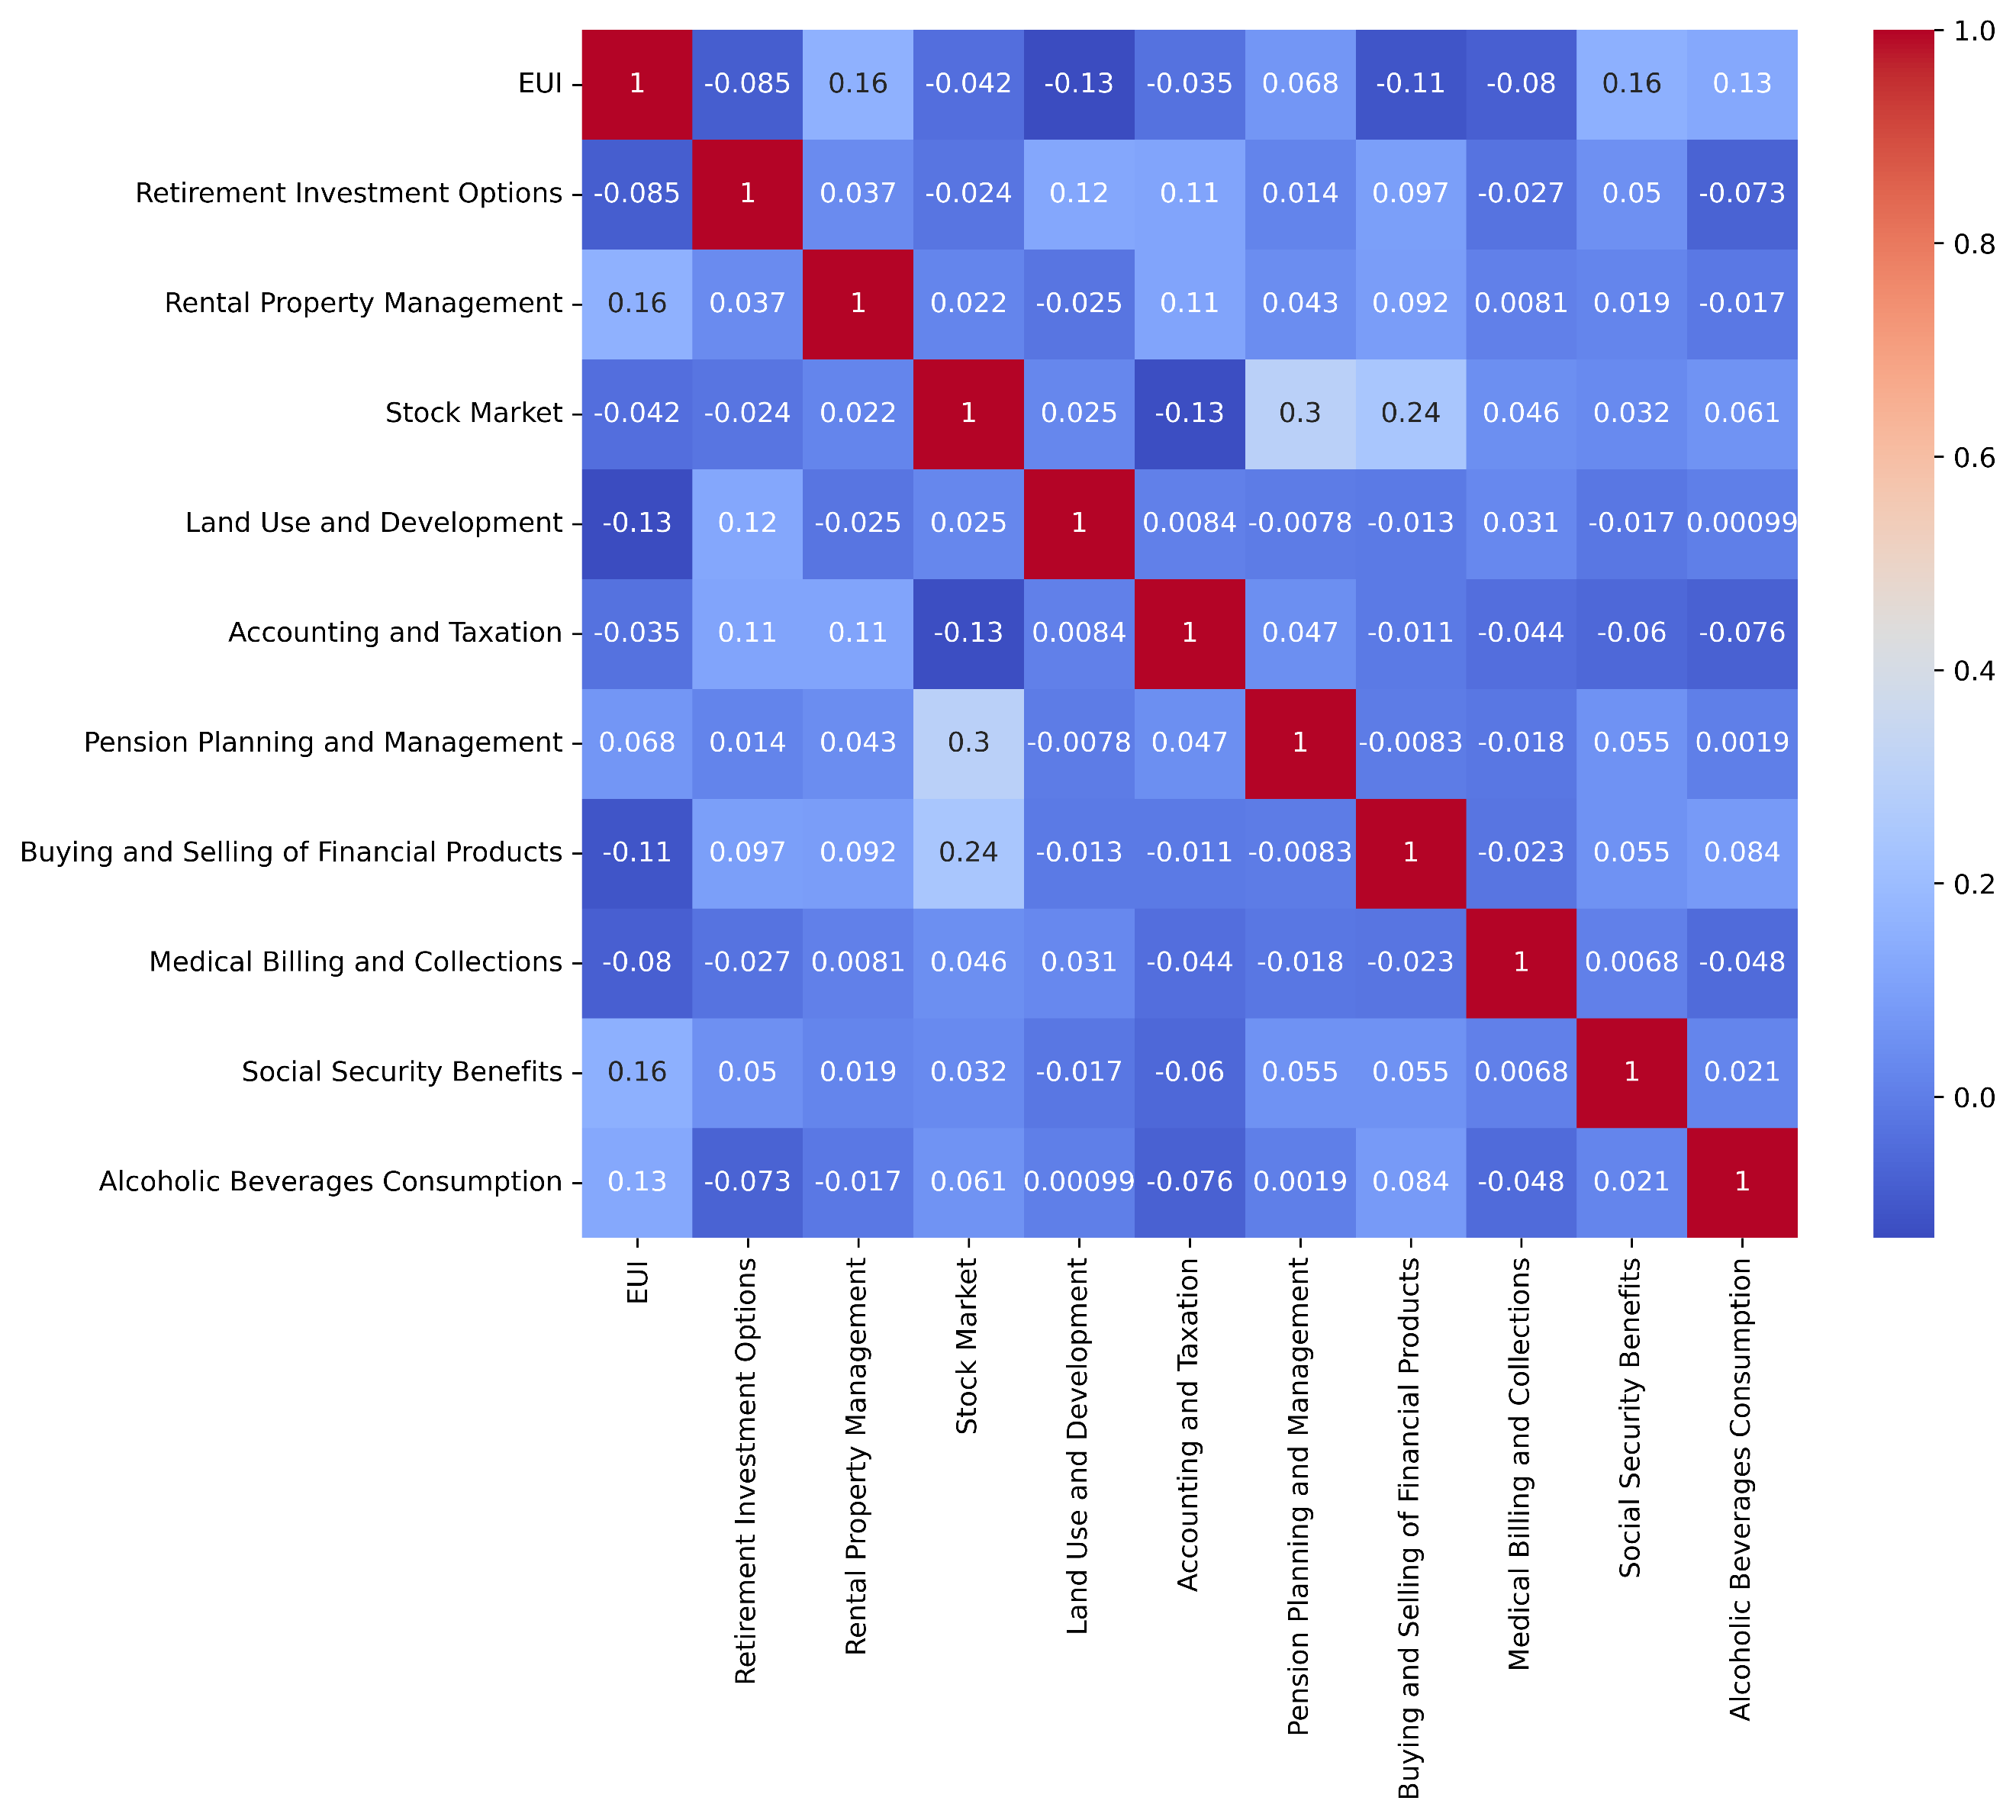
Figure 3. Correlation heatmap for EUI and the relevant topics

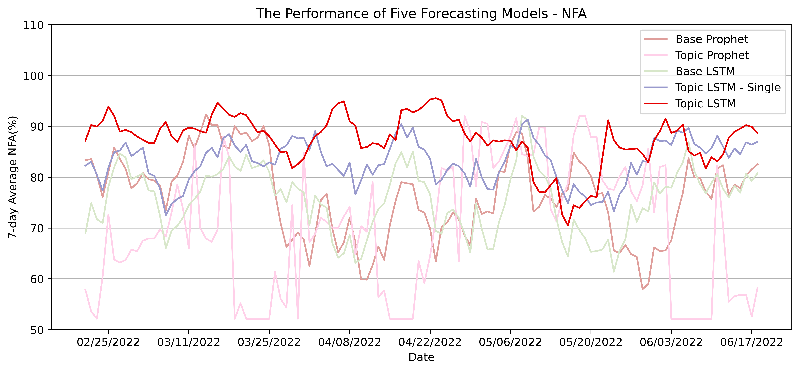
Figure 3. 7-day average NFA for all five models w. 90-day Training Period

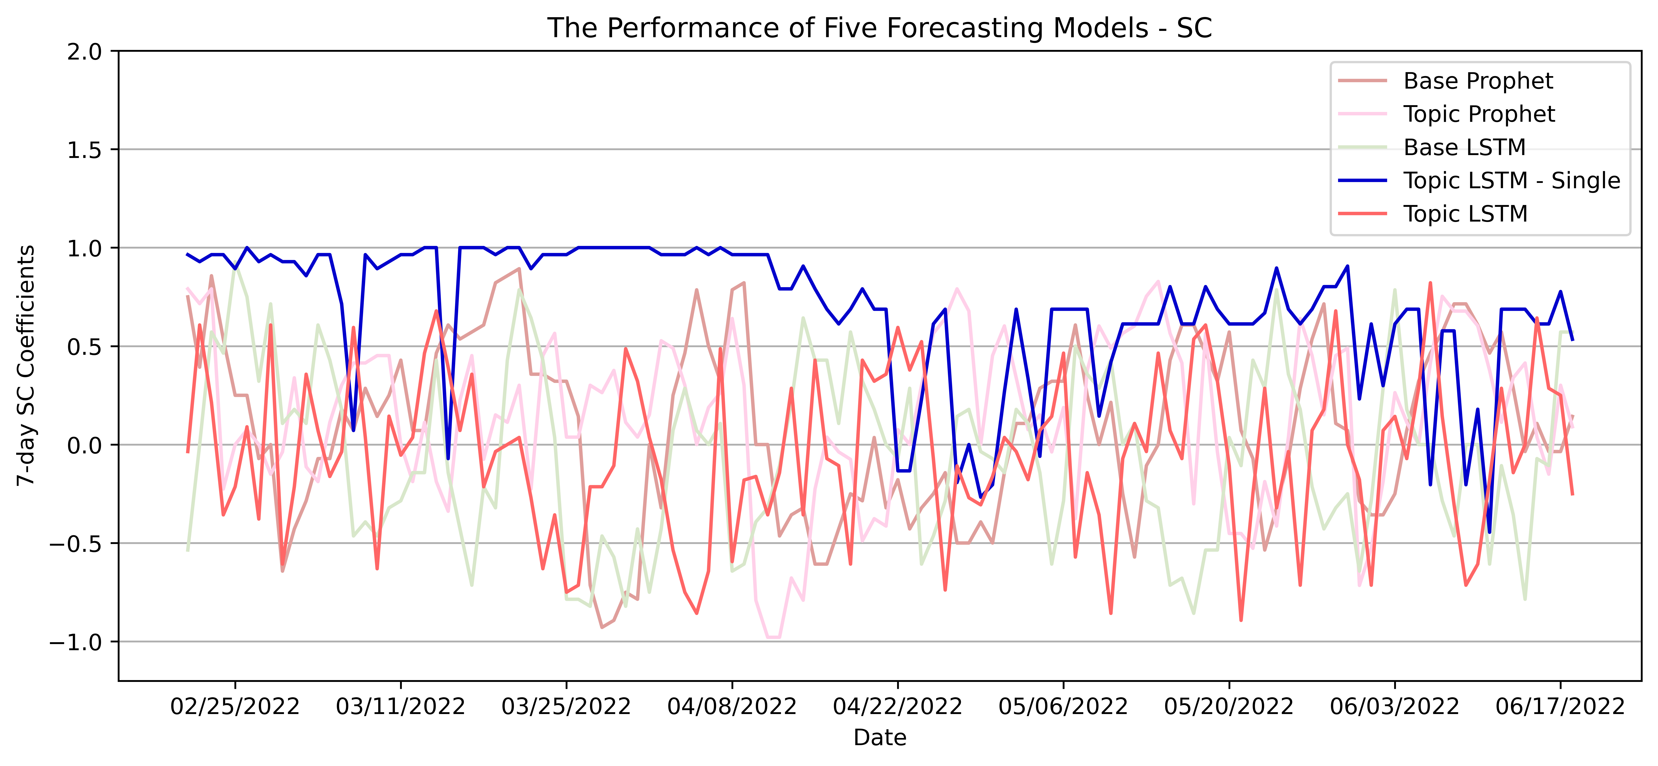
Figure 5. 7-day SC for all five models w. 90-day Training Period

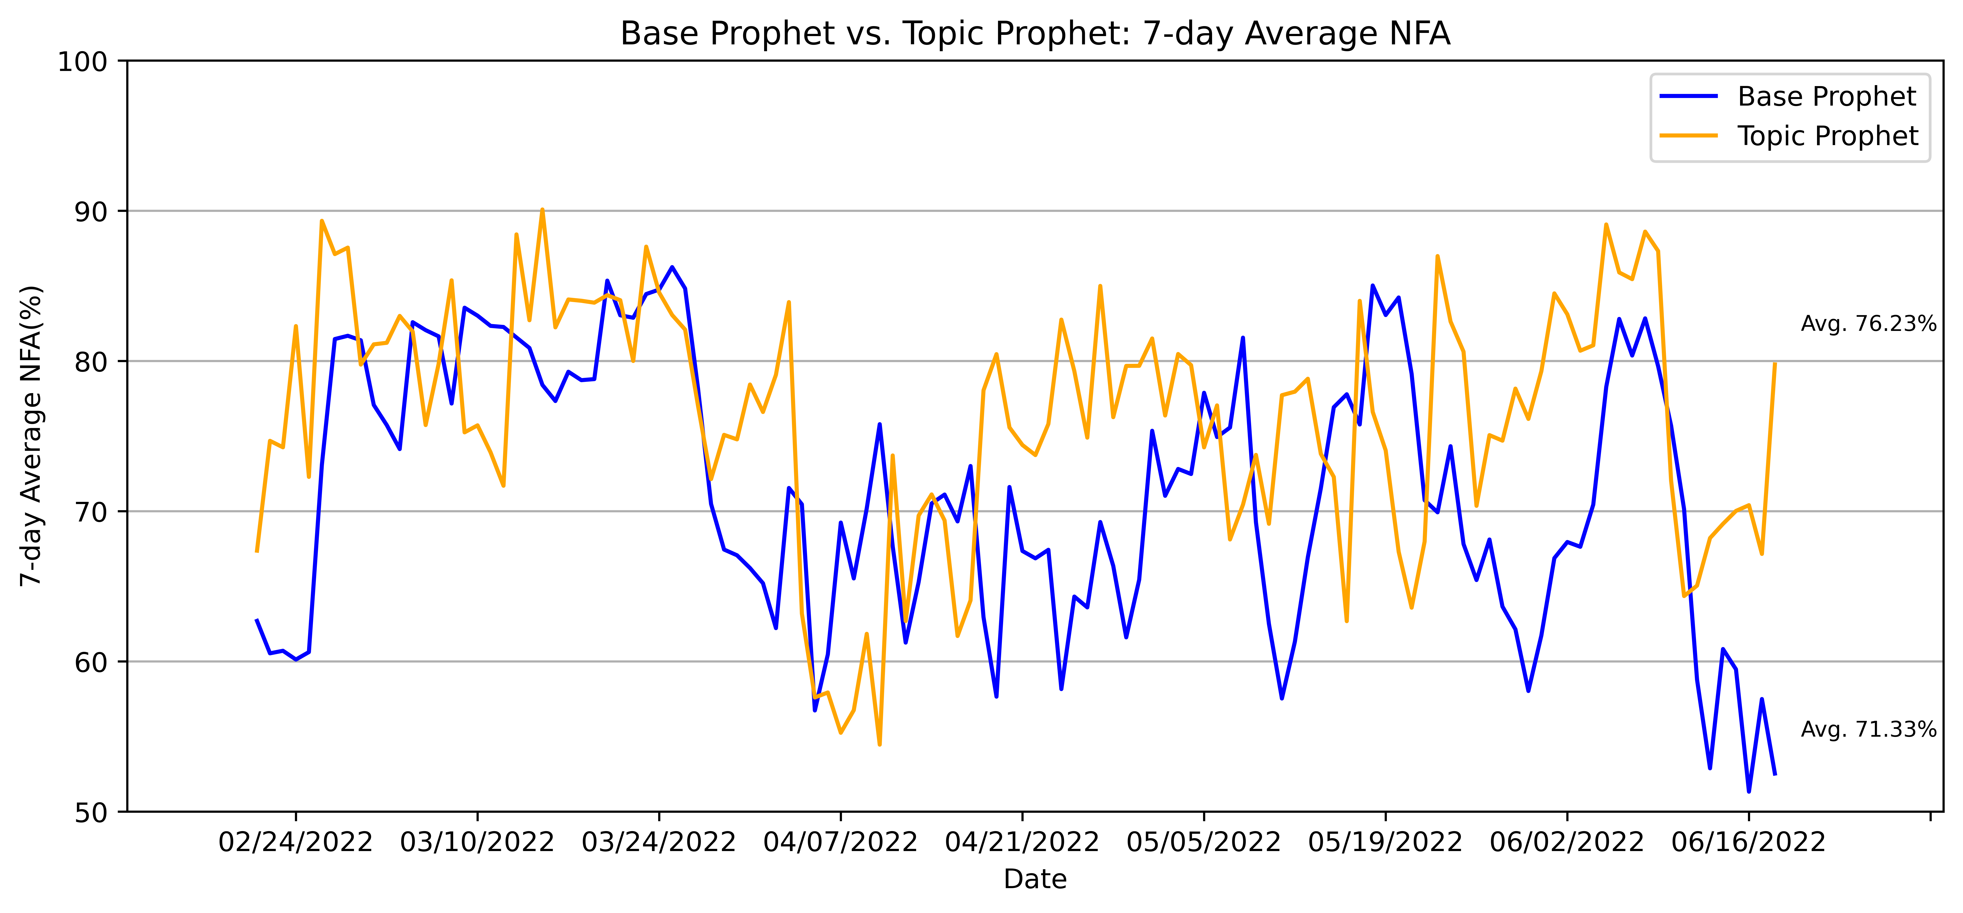
Figure 6. 7-day NFA of Base Prophet and Topic Prophet w. 28-day Training Period

List of tables:

Table 1. Data Summary
Total Records | Total Tokens | Daily Avg. # Users | Daily Avg. # Records | Daily Avg. # Unique Posts
1,228,571 | 71,316,874 | 2,717 | 5,714 | 455

Table 2. (a) Cross Validation Results – NFA (%)
Number of Original Topics | 1-day after | 3-days after | 7-days after
10 topics | 75.4 ± 2.40 | 73.27 ± 1.21 | 73.01 ± 1.01
30 topics | 75.18 ± 2.71 | 72.98 ± 0.39 | 73.59 ± 1.11
50 topics | 75.24 ± 0.88 | 72.84 ± 1.82 | 72.79 ± 2.53
100 topics | 74.89 ± 0.24 | 73.79 ± 0.16 | 73.30 ± 1.53
200 topics | 75.25 ± 2.89 | 74.25 ± 1.34 | 73.92 ± 1.26
2504 topics | 77.18 ± 0.59 | 74.74 ± 0.92 | 74.54 ± 1.79

Table 2. (b) Cross Validation Results – Spearman Correlation
Number of Original Topics | 1-day after | 3-days after | 7-days after
10 topics | 0.2233 ± 0.0893 | -0.0626 ± 0.0898 | 0.0815 ± 0.0395
30 topics | 0.2064 ± 0.1251 | -0.0395 ± 0.0978 | 0.1299 ± 0.1216
50 topics | 0.2601 ± 0.0912 | -0.0966 ± 0.0991 | -0.0264 ± 0.1467
100 topics | 0.2542 ± 0.0966 | 0.0175 ± 0.1130 | -0.0052 ± 0.1074
200 topics | 0.2615 ± 0.0900 | 0.0509 ± 0.0743 | 0.0637 ± 0.0622
2504 topics | 0.3130 ± 0.0459 | 0.0164 ± 0.2049 | 0.2041 ± 0.1421

Table 3. Summary of Overall Model Performance with 90-day Training Period
Forecasting Models | Average NFA (%) | SC
7-day Base Prophet | 76.24 | 0.0944
7-day Topic Prophet | 69.80 | 0.1472
7-day Base LSTM | 75.52 | -0.0475
1-day Topic LSTM – Single | 84.19 | 0.6846
7-day Topic LSTM | 87.36 | -0.0410

